**Customer Segmentation**

**Objective**: To build a Machine Learning Model to develop a customer segmentation to define marketing strategy..

**Model Implementation**: KMeans Clustering, Primary Contact Analysis, Silhouette Score

**Silhouette Score**: **87%**

**Key Insights:**

Based on the elbow curve, it appears that the within-cluster sum of squares (WSS) decreases sharply up to 3 clusters and then starts to level off. This suggests that 3 clusters may be an optimal choice for the given data, as it provides a good balance between the level of clustering and the complexity of the model. However, 2 or 4 clusters may also be reasonable choices depending on the specific goals of the analysis

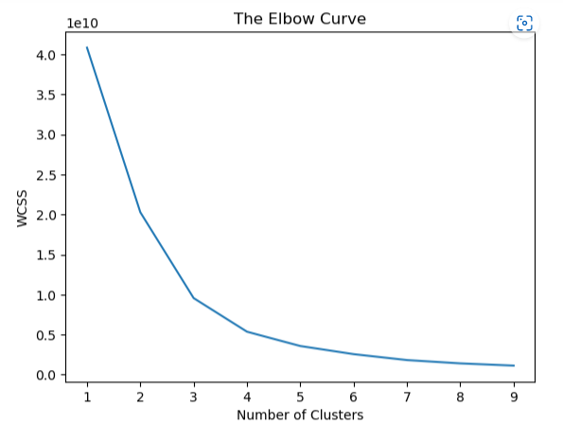

The silhouette score graph shows that K=2 has a higher score than K=3 or K=4, indicating that K=2 may be the best choice for the number of clusters in the data.

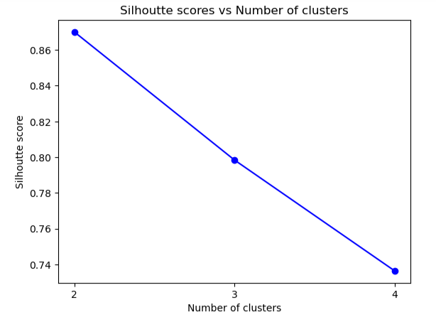

From the scatter plot below, we can clearly segment the customers based on one off purchases and purchases made

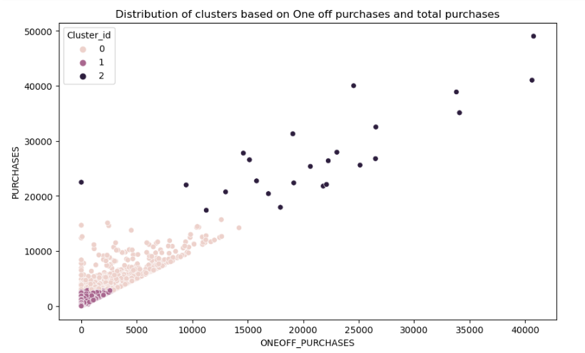

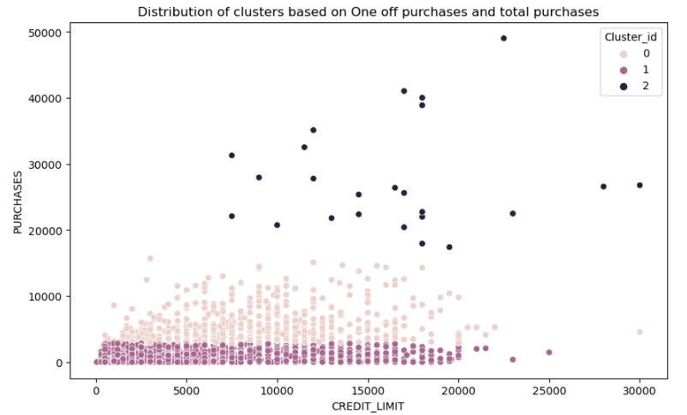

The data analysis has identified three distinct groups of customers based on their credit card usage patterns. The first and second group consists of customers who have high credit card usage, and the third group consists of customers who have very low credit card usage. Targeting these groups separately can help in developing effective marketing strategies and improving customer engagement. This approach can lead to better utilization of resources and increased revenue for the business.